|  |
| --- |
| Name: GPDCM Jayasekara |
| Student Reference Number:10707085 |



|  |  |  |
| --- | --- | --- |
| Module Code: PUSL2008 | Module Name: Introduction to Internet of Things | |
| Coursework Title: Introduction to Internet of Things Project Final Report | | |
| Deadline Date: 19 April 2021 | | Member of staff responsible for coursework:  Dr.Chandana Perera |
| Programme: BSc (Honours) Software Engineering / BSc (Honours) Computer Networks /  BSc (Honours) Computer Security | | |
| Please note that University Academic Regulations are available under Rules and Regulations on the University website [www.plymouth.ac.uk/studenthandbook](http://www.plymouth.ac.uk/studenthandbook). | | |
| Group work: please list all names of all participants formally associated with this work and state whether the work was undertaken alone or as part of a team. Please note you may be required to identify individual responsibility for component parts.  GPDCM Jayasekara - 10707085  BKDN Samarasinghe - 10707052  VPN Sulakshika - 10707385  HS Kaushalya - 10707241  PDS Sigera - 10707372  ***We confirm that we have read and understood the Plymouth University regulations relating to Assessment Offences and that we are aware of the possible penalties for any breach of these regulations. We confirm that this is the independent work of the group.***  Signed on behalf of the group: A picture containing diagram  Description automatically generated | | |
| Individual assignment: ***I confirm that I have read and understood the Plymouth University regulations relating to Assessment Offences and that I am aware of the possible penalties for any breach of these regulations. I confirm that this is my own independent work.***  Signed: | | |
| Use of translation software: failure to declare that translation software or a similar writing aid has been used will be treated as an assessment offence.  I *have used/not used translation software.  If used, please state name of software………………………………………………………………… | | |
| **Overall mark _____% Assessors Initials ______ Date_________** | | |

*Please delete as appropriateSci/ps/d:/students/cwkfrontcover/2013/14

# ROBOTIC ARM & ELDERLY SUPPORT SYSTEM - FINAL REPORT

## ABSTRACT

* The first industrial robot (robotic arm) was built by the late Joseph F. Engelberger together with inventor George Charles in 1959. They named their prototype as Unimate#001. Later, many inventors made many improvements to this great innovation. Since, the robot arm has been used in numerous industries in order to put ease on human tasks.
* Assistive robotic arms or self-feeding robotic arms have become very helpful devices for the people who have difficulty in moving such as elderly or disabled individuals and they also are being modified for further purposes. So, when it comes to the robotic arm and elderly support system, we specially designed this for elderly individuals who have difficulty in moving. And for the arm we placed there a spoon so that the robot can feed the person. This can be mostly used for liquidlike food items like soup.
* This robotic arm and elderly support system are controlled by an android application which's name is “HACE APP”. This application has 1 main interface and 2 sub interfaces. These are “Home” interface and “Arm” interface. Using this “Home” interface, elderly individuals can on/off their room’s bulb, fan and they can take emergency calls. The “Arm” interface is used to control the robotic arm.
* The robotic arm can store the directions of the arm, and after storing those data in the android device it will be connected to the robotic arm using the Bluetooth interface. The HACE APP acts as the control panel of the robotic arm and it gives commands to the circuit and the circuit instructs the motors to move the robotic arm. There are components like the hardware and software tools that we used when made the project.

Contents

ROBOTIC ARM & ELDERLY SUPPORT SYSTEM - FINAL REPORT 2

ABSTRACT 2

LIST OF TABLES 4

CHAPTER 1 – INTRODUCTION 5

1. PROJECT NAME AND DESCRIPTION 5

2. GROUP DETAILS 6

3. PROJECT OBJECTIVES 7

4. SCOPE OF THE PROJECT 8

5. TIMELINE 8

CHAPTER 2 - SYSTEM DEVELOPMENT 9

1. SENSOR INTEGRATION 9

2. MOBILE APPLICATION DEVELOPMENT 10

3. INTERNET CONNECTIVITY 10

4. DATA STORAGE USING CLOUD TECHNOLOGY 10

5. CREATE SEPARATE TABLE FOR EACH MEMBER. 11

CHAPTER 3 – IMPLEMENTATION 16

1. PROJECT GITHUB LINK (OR SHARABLE LINK) 16

https://github.com/InternetOfThings-Project/Robotic-Arm-Elderly-Support-System.git 16

2. IMPLEMENTATION OF THE SYSTEM 16

CHAPTER 4 - SYSTEM TESTING AND QUALITY ASSURANCE 18

CHAPTER 5 - CONCLUSION AND FURTHER WORK 23

1. CONCLUSION 23

2. LIMITATIONS 23

3. FURTHER WORK 24

CHAPTER 6 - APPENDIX 25

1. REFERENCES 25

2. SOURCE CODE 26

3. SCREENSHOTS AND IMAGES 28

END 33

## LIST OF TABLES

*(table 1)* – Member 1 details.

*(table 2)* - Member 2 details.

*(table 3)* - Member 3 details.

*(table 4)* - Member 4 details.

*(table 5)* - Member 5 details.

## CHAPTER 1 – INTRODUCTION

### PROJECT NAME AND DESCRIPTION

* Project Name: **ROBOTIC ARM & ELDERLY SUPPORT SYSTEM**
* Our project is robotic arm and elderly support system which are based on Arduino, providing the capability to spoon-feed an elderly individual which is controlled by an android mobile application that uses Bluetooth interface in-order to connect the arm. The android application acts as the control panel of the robotic arm and the control panel of the elderly support system. It is used to move the robotic arm upward and downward directions. The android application gives commands to the circuit and the circuit instructs the motors to move the robotic arm. On the other hand, this mobile application can be used to control the room automation system. There is a bulb and a fan which can be turned on and off, a temperature and a humidity checker, a medication reminder and an emergency calling system.
* Since an elderly individual might have difficulties in moving fingers and talk, we only focus them to make a single move on the desired button of the application. This arm is suitable for liquid food items like soup. To make the arms work firstly the base, shoulder, elbow, and grip movements should be recorded and saved in the UNO. Then the elderly individual has the right to tap on the desired button and playback the recorded movement. Then the robotic arm will take the spoon from the bowl to the mouth. After the person has had enough then, he can press stop in-order to shut down the arm. The elderly individual has the right to tap on the desired button to take emergency calls, check temperature & humidity and on/off a bulb & fan. This is the overall idea of the project that we work on.
* Also, the android application has some features in it like we use the cloud technology to store data to make a communication process between the app and the user. The main UI is used to control the robotic arm and the other UI is designed to give more uses to the user for using the app. It has a light system where if we click on the bulb icon in the app a bulb will turn on and it is same with the fan too. If the user wants to turn on the fan, he can click on the fan icon. Also, we have set a reminder for medications. Where the user must first enter the required information and then the alerts will work accordingly. Next there is an emergency call icon where there are three numbers saved in the phone and then the user can select the appropriate number and then make the call.

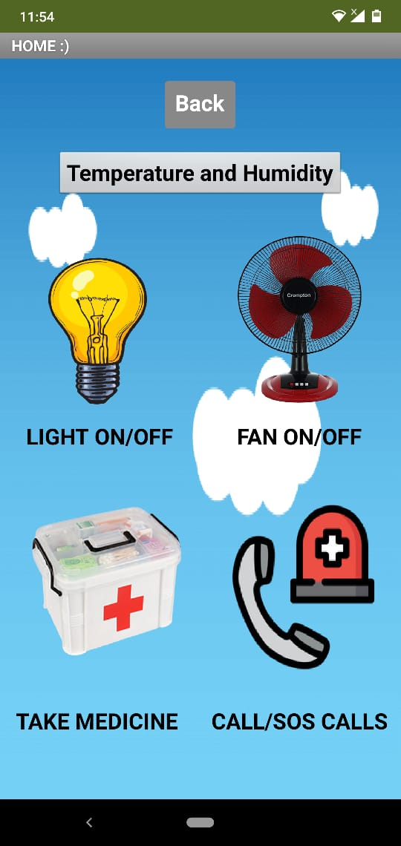

### GROUP DETAILS

GPDCM Jayasekara - 10707085

BKDN Samarasinghe - 10707052

VPN Sulakshika - 10707385

HS Kaushalya - 10707241

PDS Sigera - 10707372

### PROJECT OBJECTIVES

* The main objective is to make sure that the robot arm and elderly support system works accordingly and to make the project a success.
* Also, to become a helping hand to elderly individuals.
* To provide a service where there is no human involvement.
* To provide a service to who is very old.
* To made robots user-friendly.
* To make the robotic arm at the lowest possible cost.
* The robotic arm and mobile application are easy to use and manipulate.
* To provide a safe and secure service.
* To make sure that the spoon directly feeds the user.
* Since its a robot arm and elderly support system they can be used at any time as the user want.
* To feed the user safely without adding too much technical methodologies.
* This self-feeding robotic arm is a simple device that we produce with the simplest capabilities. So, as it is said the arm can be used to feed only liquid item like soup where the arm takes some amount of soup to the spoon and then feeds the user.
* The purpose of the project is to become a helping hand for a person in need. It is a simple Arduino based robot arm and elderly support system controlled with the help of an android system. With the help of this android application a person can operate a bulb and fan on/off by a single touch and can take emergency calls by a single touch. With the help of this machine a person can operate the system by a single touch. So, after clicking the desired the button the robot will follow the order given to him by the android system which is controlled by the user.

### SCOPE OF THE PROJECT

* It important to maintain the speed of the arm because when the robot arm is feeding the person, we expect the speed to be balanced and the spoon to be correctly fed to the disabled person. The arm should not move too fast or too slow that the person might even feel uncomfortable when eating. Therefore, we hope that our robot will feed the person without making the user uncomfortable and safely.
* We expect all the functionalities of the app to work properly like all the buttons and the Bluetooth connectivity.
* We expect not to make the app too complex so that everyone can use the app as they want with connected to the arm.

### TIMELINE

|  |  |  |  |  |  |  |  |
| --- | --- | --- | --- | --- | --- | --- | --- |
| **TIME**  **TASKS** | **March**  **Week1**  **2021** | **March**  **Week2 2021** | **March**  **Week3**  **2021** | **March**  **Week4 2021** | **April**  **Week1 2021** | **April**  **Week2 2021** | **April**  **Week3 2021** |
| **Planning & Organizing** |  |  |  |  |  |  |  |
| **Resource Allocation** |  |  |  |  |  |  |  |
| **Robot Development** |  |  |  |  |  |  |  |
| **Sensor Integration** |  |  |  |  |  |  |  |
| **Interface Designing** |  |  |  |  |  |  |  |
| **Mobile-App Development** |  |  |  |  |  |  |  |
| **Testing & Debugging** |  |  |  |  |  |  |  |
| **Project Finalization** |  |  |  |  |  |  |  |

## CHAPTER 2 - SYSTEM DEVELOPMENT

### SENSOR INTEGRATION

* For reading the room temperature and humidity, we found that DHT 11 sensor is the best device for that.

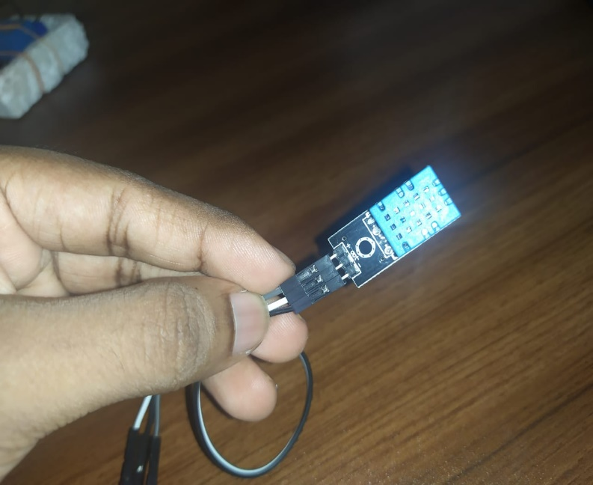

Figure 1 DHT 11 Sensor

* We connected DHT11 with NodeMCU model and uploaded the code. Thereafter, we can read the temperature and humidity via the application.

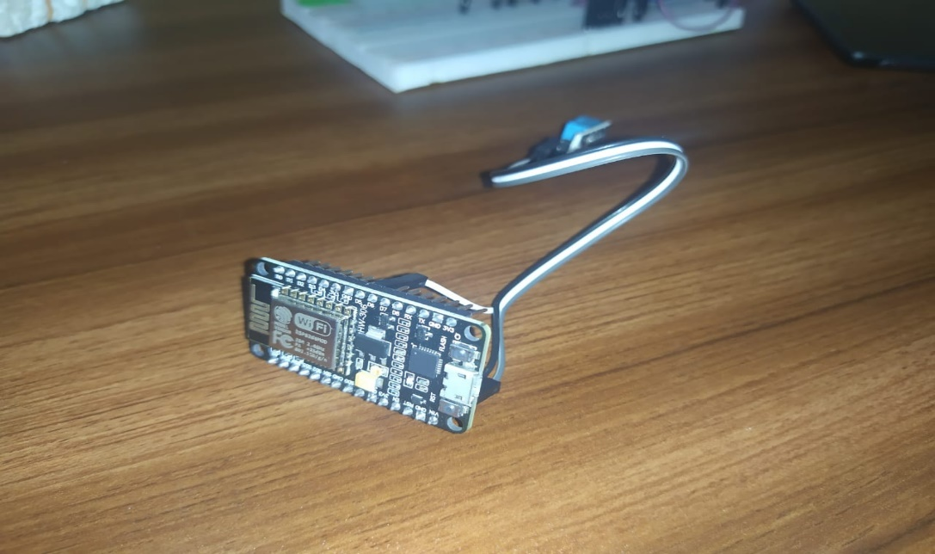

Figure 2 Connected with Node Mcu

### MOBILE APPLICATION DEVELOPMENT

* We used MIT app inventor for application development there. There we added some features like FireDB and Bluetooth to the application. We found that MIT app inventor is a easiest way to build the application and found that it support to connect with third party cloud services like Firebase.

### INTERNET CONNECTIVITY

* For the internet connectivity, we used Nodemcu as it is compatible for Wi-Fi connectivity. Here, to connect with the app and the board together, we used few libraries like ESP8266WiFi.h in Arduino coding.

### DATA STORAGE USING CLOUD TECHNOLOGY

* In Cloud Technology, we used Firebase there and for the database, we used Real time database instead of Cloud Database. We experienced that Real time database is more accurate than the Cloud Database.

### CREATE SEPARATE TABLE FOR EACH MEMBER.

|  |  |
| --- | --- |
| Name | GPDCM Jayasekara (Group Leader) |
| Plymouth ID | 10707085 |
| Completed tasks | Robot Arm Building, Arm Wiring, Sensor connection (Done with BKDN Samarasinghe) Fire-Base Connection, Light On/Off of Home Automation |
| Used technologies | Arduino, Fire Base Cloud, MIT app inventor 2, Light Sensors |
| Accrued skills and knowledge | How to build a robotic arm accordingly and setting it up to the requirement.  How to attach servo motors and make them work.  How to connect sensors to the board and make use of it.  How to connect the app and send and store while it can also retrieve data form the cloud and display it. |

*(table 1)*

|  |  |
| --- | --- |
| Name | B K D N Samarasinghe |
| Plymouth ID | 10707052 |
| Completed tasks | Robotic arm wiring, Robotic arm building, Temperature & Humidity, Arm Designing, Overall Testing, Home automation fan |
| Used technologies | Arduino UNO, Bluetooth, NodeMCU(ESP8266),DHT11, Relays |
| Accrued skills and knowledge | Studied Communication with Bluetooth.  Learnt to plan and design breadboard design with wiring to fulfil requirements.  Studied how Nodemcu and Firebase work together in few scenarios like DHT 11 reading, Light ON/OFF etc |

*(table 2)*

|  |  |
| --- | --- |
| Name | V P N Sulakshika |
| Plymouth ID | 10707385 |
| Completed tasks | Created the mobile application (Arm, Light, Emergency). |
| Used technologies | SCRATCH & MIT App Inventor |
| Accrued skills and knowledge | Learnt, how to create a mobile application using MIT App Inventor & Scratch. |

*(table 3)*

* My contribution of this Robotic Arm & Elderly Support System Project, Created the **Robotic Arm**, **Light system**, and **Emergency system in the android application**.
* I did not be doing any coding process during creating this app and I did assemble blocks together to make this app.
* I used scratch for back-end coding for this app.
* Created this app using MIT app inventor, I can connect the app with Arduino to make things work.

**Robotic Arm System**

* In here, I used 4 servo motors, and these are working with 4 sliders and I used 2 buttons for, connect to the Bluetooth and disconnect Bluetooth.
* In this application, I used 3 buttons for program save, run, and reset.
* Once we press the run button and create sliders for correct positions, press pause button and press save button, we can save our record.
* After pressing reset button, we can clear saved all data and we can save positions multiple times.

**Light System**

* In here, I used 2 buttons for ON / OFF the bulb and 1 button for back to the main page.
* Once we press the **ON** button, the bulb will be switched on and when we press the **OFF** button, the bulb will be switched off.

**Emergency Calling System**

* In here, I used 3 buttons for call Ambulance, E-Channelling and Police.
* When the elderly individual need to take call for an Ambulance, E-Channelling or Police, he / she can take calls using by a single touch.

|  |  |
| --- | --- |
| Name | H S Kaushalya |
| Plymouth ID | 10707241 |
| Completed tasks | Did the Arduino Coding |
| Used technologies | Arduino IDE |
| Accrued skills and knowledge | Learnt a new programming language and how to work in a team. |

*(table 5)*

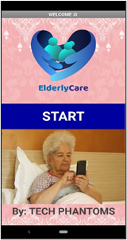

* My contribution to the project is making the main UI, Fan Controller, and a Reminder to take medicines.
* This is the main UI of the app. There is a start button so by clicking on the button the user can proceed.

further and this is the starting point of the app.

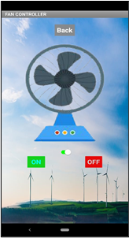

* The next part is the fan.
* Here there is a back button with an image and there is an ON and OFF button. So, if the user clicks on the ON button the fan will be switched on while the OFF button switches off the fan.

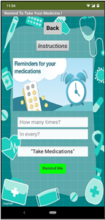

* Next there is a medication reminder.
* Here the user will have to insert some data of how many times does he/she needs to get the medicine and in which hour.
* Then there will be a reminder getting to the user after calculating the entered number of hours with the last reminded time and this process will continue until the inputs are changed.

|  |  |
| --- | --- |
| Name | P D S Sigera |
| Plymouth ID | 10707372 |
| Completed tasks | Mobile Application (Home), Banner, Resource Gathering |
| Used technologies | MIT App Inventor and Scratch to design and create the home page.  Research of journal and articles for more clarifications. |
| Accrued skills and knowledge | Learnt how to design using MIT App Inventor.  Learnt how to work in a team |

*(table 4)*

## CHAPTER 3 – IMPLEMENTATION

### PROJECT GITHUB LINK (OR SHARABLE LINK)

### <https://github.com/InternetOfThings-Project/Robotic-Arm-Elderly-Support-System.git>

### IMPLEMENTATION OF THE SYSTEM

Building Robotic Arm and Wiring

* We successfully collected the requirements like acrylic sheets, trimmed into pieces and assembled them into together and finally built the robotic arm that can house the servos.
* We used Arduino UNO as a source of computing model for this robotic arm operation and used HC-05 Bluetooth model for connectivity.
* We used an external power supply which is 5v and 2A to support all four servos as we found that Arduino UNO cannot power all the servos itself.
* Each Servos got three wires named, power, ground, and signal wires, we used to connect power and ground to breadboard powered with external power source and signal wires to the UNO board.

DHT Sensor for Room Temperature and Humidity Data Readings

* We used DHT 11 Sensor model and chosen Node-Mcu board as source of computing model as we found it is compatible for WIFI connectivity.
* DHT 11 Sensor model has its own 3.3K Resistor, so it is safe to power 5v by Nodemcu itself. DHT 11 Sensor has 3 pins named as, Positive, Negative and Signal. We wired all those pins into 5v pin, GND pin and D5 pin for Signal.

Relay Module for Home Automation (Light, FAN ON/OFF)

* We used a 2 channel 5v Relay module to control two home appliances like Light and Fan.
* In front side of Relay module, it got four pins like GND, VCC, IN1, and IN2 pins to make connections with Node MCU.

Relay Module 🡪 NodeMCU

GND 🡪 GND

VCC 🡪 VIN

IN1 🡪 D1

IN2 🡪 D2

* In back side of the Relay Module, it got 3 outputs named, COMM, NC and NO to connect any electrical appliances like light, fan etc.

Relay Module 🡪 Home Appliances (Light Bulb)

COMM – Line Wire coming from the electric socket side.

NO (Normally Open) 🡪 Line wire coming from the Bulb side.

* The Android Controlled Robotic Arm mobile application is already created and, it is working properly.
* We used MIT App Inventor to make the application.
* We will not be doing any coding process during creating this app and we will be assembling blocks together to make this app.
* We used scratch for back-end coding for this app.
* Create this app using MIT app inventor, we can connect the app with Arduino to make things work.
* In here, we use 4 servo motors, and these are working with 4 sliders and we use 2 buttons for, connect to the Bluetooth and disconnect Bluetooth.
* In this application, we used 3 buttons for program save, run, and reset.
* Once we press the run button and create sliders for correct positions, press pause button and press save button, we can save our record.
* After pressing reset button, we can clear saved all data and we can save positions multiple times.

## CHAPTER 4 - SYSTEM TESTING AND QUALITY ASSURANCE

1. TESTING APPROACHES AND METHODOLOGIES

* This whole robot uses joints as arms that able to span over four (4) axis directions such as up, down, left, right and one arm part called gripper can hold and release too. This robot arm can be used as a pick and place object, but our project was intended to make this able to feed food to disabled or elderly people, therefore, we must place a spoon on either side of the gripper. The source of computer, Arduino UNO is used to provide quintessential control of the robotic arm.

* After completion of the setup and the tests take places like security testing, control testing and accessibility testing.

* When coming to the security testing, due to this project based on servo motors, there is higher chances that it would turn out to be dangerous. To minimize we thought, since this is controlling under the command we give, we abled set up the delay time, the time that spend reaching a position, a longer, so it would move slowly and safely. Next, in case the user feels not safe with robot arm, we had set up a button on interface says, “RESET”, as it acts as a kill switch that able to break the whole operation.

* In control testing, we were successful to set up a simple interface when user can easily control of the robotic arm. First, we had used some buttons indicating degrees like 15,30,45 and gave a try. Our expression with that we felt that it requires more smoother control. As a result of that, we have used slider option, so user can just move slider, so the robot arm can reach the points so smoothly.

* Accessibility testing, a critical factor that shown up in this whole project, as we want to make this easily to reach position where the user’s mouth as known as mouth position. Robot arm can have maximum length to reach. We tested this arm without mounted on a box, just barely on the tabletop, the arm cannot reach that much higher as user have to face down. So, we understood that user should get comfortable, so we have mounted this on a strong box. It was able to reach the intended position.

1. TEST CASES

|  |  |  |  |  |  |  |  |  |  |  |  |  |  |  |  |  |
| --- | --- | --- | --- | --- | --- | --- | --- | --- | --- | --- | --- | --- | --- | --- | --- | --- |
| **Created By** | Group 10 | | | **Test Case Description** | | | | | Android Controlled Robotic Arm | | | | | | | |
|  |  |  |  | |  |  |  |  | |  |  | |  | |  | | |
|  |  |  |  | |  |  |  |  | |  |  | |  | |  | | |
| **Tester's Name** | BKDN Samarasinghe | | | **Date Tested** | | | | | 17 / 2 / 2021 | | | **Test Case (Pass/Fail/Not Executed)** | | | | Pass |
|  |  |  |  | |  |  |  |  | |  |  | |  | |  | | |
| **Test Scenario** | Controlling the robot arm by using an android app using Bluetooth. | | | | | | | | | | | | | | | |
|  |  |  |  | |  |  |  |  | |  |  | |  | |  | | |
| **Step #** | **Step Details** | | | **Expected Results** | | | | | **Actual Results** | | | | | **Pass / Fail / Not executed / Suspended** | | |
| 1 | Making the hardware of the robot arm | | | To make the arm | | | | | As Expected | | | | | Pass | | |
| 2 | To connect the arm with sensors and the Arduino board | | | To make the arm move | | | | | As Expected | | | | | Pass | | |
| 3 | To make the android app | | | To connect the robot arm to the app and make it work with Bluetooth | | | | | As Expected | | | | | Pass | | |

|  |  |  |  |
| --- | --- | --- | --- |
| **Created By** | Group 10 | **Test Case Description** | DHT 11 Sensor |

|  |  |
| --- | --- |
| **Test Scenario** | DHT Sensor Data Validation using few tricks |

|  |  |  |  |  |
| --- | --- | --- | --- | --- |
| **Step #** | **Step Details** | **Expected Results** | **Actual Results** | **Pass / Fail / Not executed / Suspended** |
| 1 | Keeping wet cloth close to the DHT Sensor | Humidity values should gradually increasing | Humidity raised from 69% into 81% | Pass |
| 2 | Keeping lighter close to the DHT Sensor | Temperature values should gradually increasing | Temperature raised from 31*C into 36*C | Pass |

1. VALIDATION OF RESULTS

|  |  |  |  |
| --- | --- | --- | --- |
| **Validation #** | **Validation Description** | **Test Data** | **Expected Result** |
| 1 | Check response coming from Arduino module | In Arduino IDE,  Serial.begin(115200);  Serial.println(“Hello!”) | In Serial Monitor,  Hello! |
| 2 | Check response coming from Bluetooth | In Arduino IDE,  Following Software Serial, connecting respective RX and TX pin. Bluetooth.begin(115200); | Type in Serial Monitor  “Hello” and send, by Bluetooth serial monitor, can observe the result, “Hello” |
| 3 | Check if the motors are working | Simple Sweep Servo Code setting to move 90 at 1000ms delay and reach the initial position. Tried with a single servo called base. | Result in action, can observe the base turn left at 90 within 1000ms or 1 second as expected |

1. ANALYSIS OF RESULTS

* Results can be varying on different aspects of the project,
* **Checking the communication between Bluetooth module and Arduino Module (Serial Monitor)**
* With this, we must make sure the communication between Arduino module and Bluetooth module.

|  |  |  |  |
| --- | --- | --- | --- |
| **Message from Serial to Bluetooth** | **Hardware Connection** | **Message from Bluetooth to Serial** | **Connection** |
| Set the baud rate for 9600 as known as default baud rate,  “Hello Bluetooth” | Bluetooth, Power -> +5v  GND -> GND  RX pin -> TX pin (pin 11 on Arduino)  TX pin -> RX pin (pin 10 on Arduino) | Via an application called, “BT Serial”,  Connected the smartphone with Bluetooth Module.  Result - “Hello Bluetooth” | Successful |

* **Checking the servo motors goes with right angle on right time that had set in the source code (Kinetic action)**

|  |  |  |  |
| --- | --- | --- | --- |
| **Servo Motor** | **Set Angle & Delay-Time** | **Result Angle w Result Delay-time** | **Number of tries** |
| Base | Angle – 90  Delay time – 1000ms/1s | 1stResult –  Angle < 90  Time < 1s  2nd Result –  *We found the issue; the rotation was collided with obstacles like joint nuts.*  85<Angle<90  Time = 1s | 2 |
| Gripper | Angle – 30  Delay time – 1s | Got the expected result by first time in correct manner. | 1 |
| Shoulder | Angle – 45  Delay time – 1s | The expected results were shown up and the movements is close to jerky. Meaning, it’ doesn’t move that much smooth, so we had unscrewed some parts and corrected it.  Result-  Angle – 45  Delaytime – 1s | 1 |
| Elbow | Angle – 45  Delaytime – 1s | Received the expected result. | 1 |

## CHAPTER 5 - CONCLUSION AND FURTHER WORK

### CONCLUSION

* As in conclusion our project details and the overall idea is mentioned above to prove that this project would be highly successful and would be able to provide a helping hand to a disabled person or an elderly person.
* And since the app contains a HACE System we believe that it might further help the persons in need since we have provided some necessities of turning on and turning off the fan and the bulb and a reminder for medications and an emergency calling option to be done with the help of the app. So, by clicking on the desired options, they can fulfill some of the basic requirements which a disabled person might not be able to do.
* Also, we believe that since this app and the arm is designed for disabled and elderly people some might not be able to work according to the instructions and function provided. Therefore, we hope that there might be a caretaker to function the app when necessary.
* We believe that our project would help many people with various kinds of disabilities around the world and our project would facilitate them to the optimum.

### LIMITATIONS

* Also, this arm is not a 360-degree arm where the arm can turn to any angle. It can only move for 180 degrees from left to right.
* Moreover, the gripper part cannot rotate as it only opens and closes the gripper.
* Some disabled people might not be able to use and control the app if they cannot move their fingers.
* Also, some elderly people might have lack of knowledge on how to use the app.

### FURTHER WORK

* Currently have developed the arm and it is now fully controllable via a mobile app. The requirements for this project have been fully completed. And if we think of a way to further develop this project. We have planned to design it 3 times bigger to its actual size and replace the arm gripper with a fully functional hand with 5 set of fingers which can bend and turn from 3 locations using mini-servo motors this would enable the arm to lift place hold an object appropriately and even change positions as per needed. This would be the future implementation of the project. And we can guarantee that this robot arm can be used to many other tasks as well as we can make it smart so it could even operate a mobile phone.
* We can also use this arm to lift things if we remove the spoon attached to the arm like it can help an elderly or a disabled person to lift things up.
* All elderly and disable people might not be able to move their hands and fingers therefore we further move a one step forward and plans to integrate a voice system to the existing application, so that the app can be both controlled by voice and the touch of the screen.

## CHAPTER 6 - APPENDIX

### REFERENCES

* www.who.int. (n.d.). *Disability*. [online] Available at: <https://www.who.int/health-topics/disability#tab=tab_1>.
* VectorStock. (n.d.). *Disabled man in wheelchair rehabilitation of vector image on VectorStock*. [online] Available at: https://www.vectorstock.com/royalty-free-vector/disabled-man-in-wheelchair-rehabilitation-of-vector-20883252 [Accessed 25 Nov. 2020]. <https://www.vectorstock.com/royalty-free-vector/disabled-man-in-wheelchair-rehabilitation-of-vector-20883252>
* VectorStock. (n.d.). *Isolated industrial robot arm icon vector image on VectorStock*. [online] Available at: https://www.vectorstock.com/royalty-free-vector/isolated-industrial-robot-arm-icon-vector-21491140 [Accessed 25 Nov. 2020]. <https://www.vectorstock.com/royalty-free-vector/isolated-industrial-robot-arm-icon-vector-21491140>
* VectorStock. (n.d.). *Laptop tablet mobile phone with blank screen vector image on VectorStock*. [online] Available at: https://www.vectorstock.com/royalty-free-vector/laptop-tablet-mobile-phone-with-blank-screen-vector-30099644 [Accessed 25 Nov. 2020]. <https://www.vectorstock.com/royalty-free-vector/laptop-tablet-mobile-phone-with-blank-screen-vector-30099644>
* VectorStock. (n.d.). *Bluetooth icon vector image on VectorStock*. [online] Available at: https://www.vectorstock.com/royalty-free-vector/bluetooth-icon-vector-7495267 [Accessed 25 Nov. 2020]. <https://www.vectorstock.com/royalty-free-vector/bluetooth-icon-vector-7495267>
* VectorStock. (n.d.). *Beef broth soup vector image on VectorStock*. [online] Available at: https://www.vectorstock.com/royalty-free-vector/beef-broth-soup-vector-4448854 [Accessed 25 Nov. 2020]. <https://www.vectorstock.com/royalty-free-vector/beef-broth-soup-vector-4448854>

### SOURCE CODE

**ARDUINO CODES**

* <https://github.com/InternetOfThings-Project/Robotic-Arm-Elderly-Support-System.git>
* **Codes**

* **Home Automation Codes**

### SCREENSHOTS AND IMAGES

* **Screen 1**

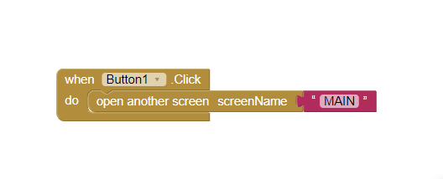

* **Main Page**

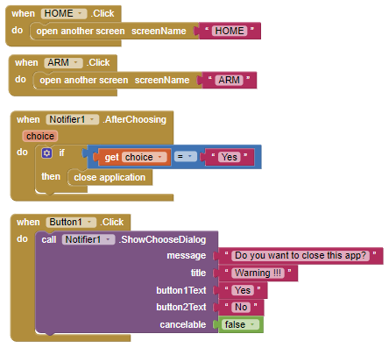

* **Arm Page**

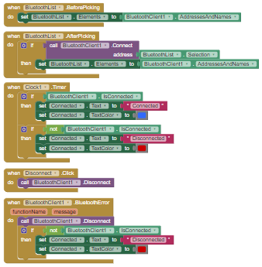

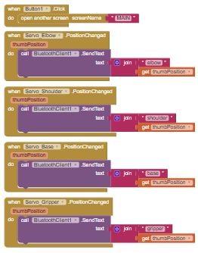

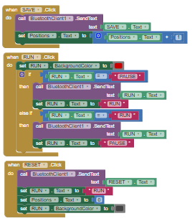

* **Home Page**

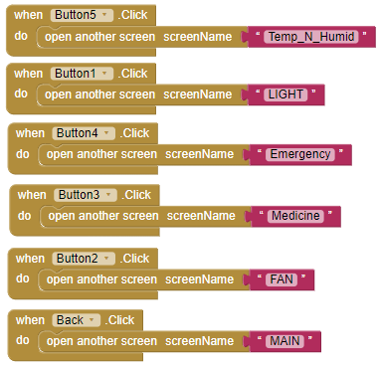

* **Temperature and Humidity Page**

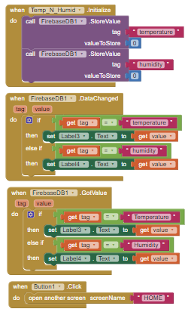

* **Light Page**

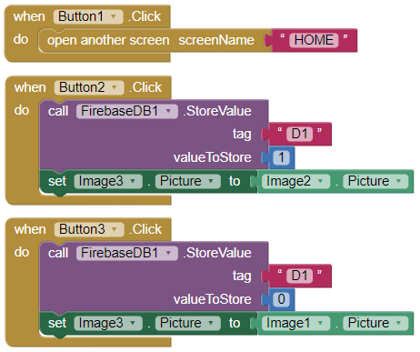

* **Fan Page**

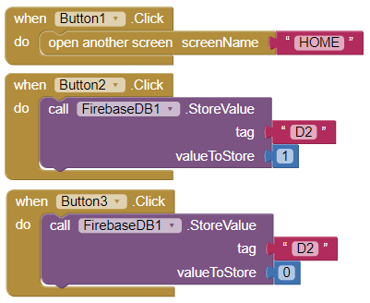

* **Medicine Remainder Page**

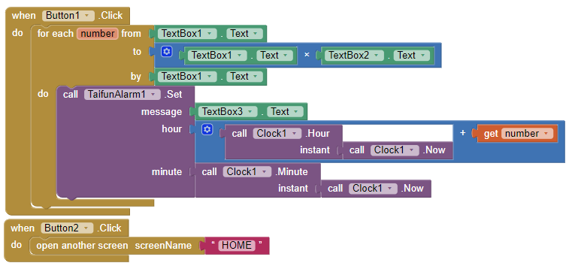

* **Emergency Call Page**

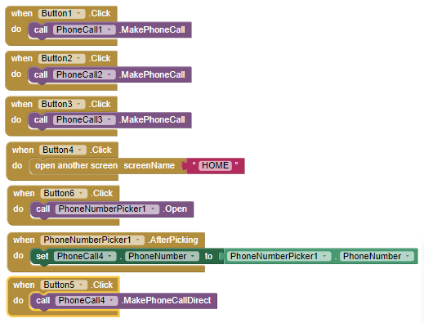

## END